WEEK 1: FRONTEND DEVELOPMENT

Task 1:

1. The page is clearly divided into nested elements. Within each tag, we open another tag according to our requirements. On close observation, it does form a tree structure, i.e., they are acyclic. The nodes of the tree are not interconnected and can only be traversed one way.

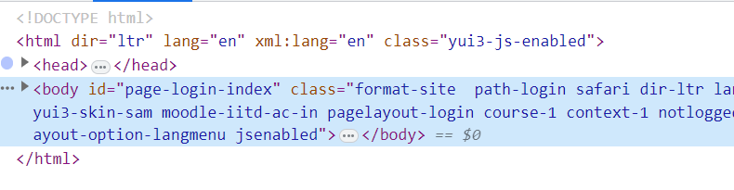

<html> tag opens the program, serving as the root vertex of the tree. Connected to it are 2 children (nodes): <head> and <body> tags.

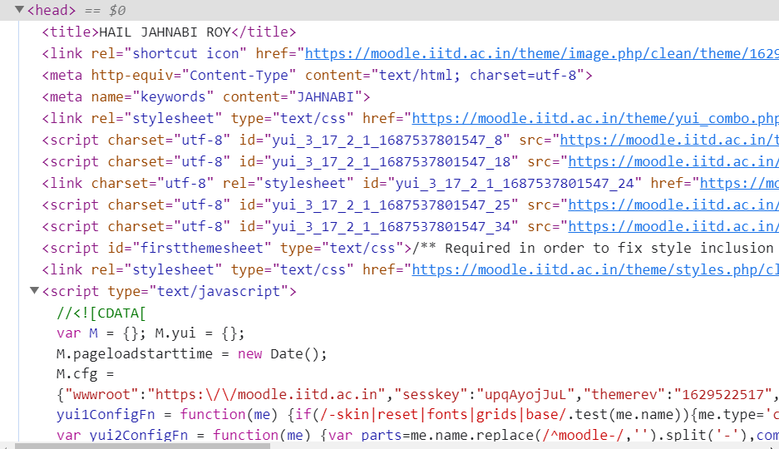

Then from the <head>, another subtree forms with root node as <head> and nodes like <title>, <meta> (of different values), <link>, <script> (different values), etc. Similar subtrees can be seen in the <body> node, in a way more extensive way.

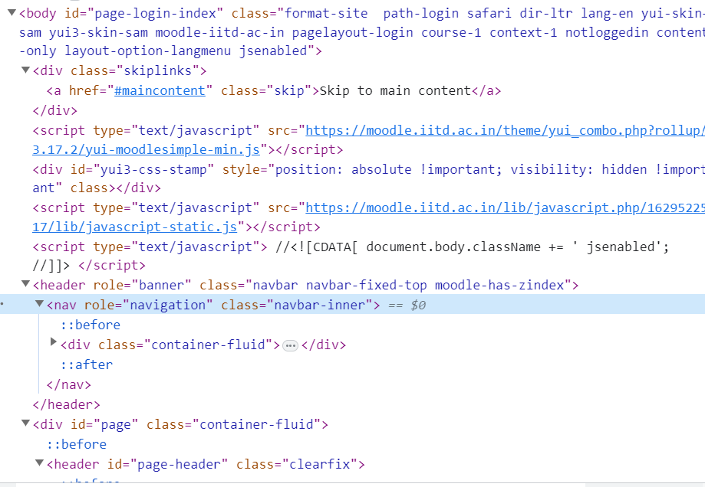

1. Playing around with the elements! : )

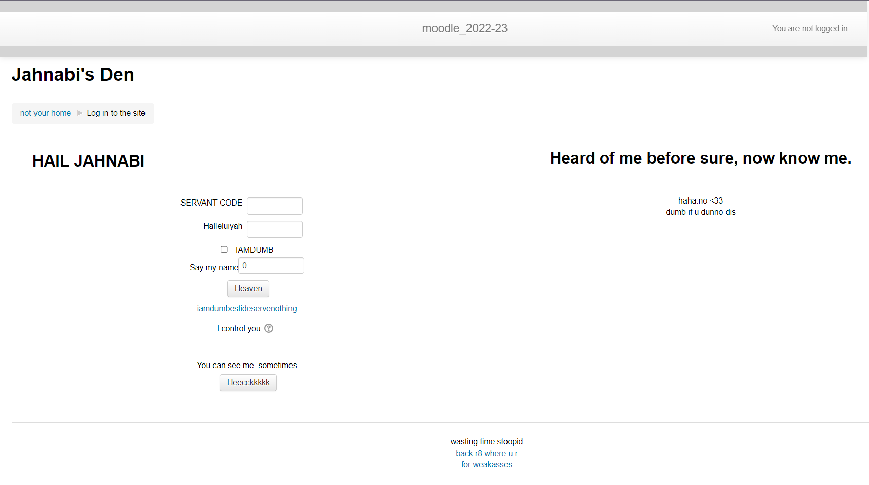

1. CSS selectors for different elements. With #(idname) operator we can find the properties corresponding to that id name (id=”idname”). With the .(classname) operator we find the CSS code corresponding to it and edit the properties corresponding to that class (class=”classname”).

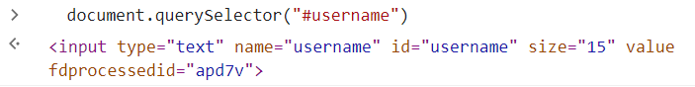

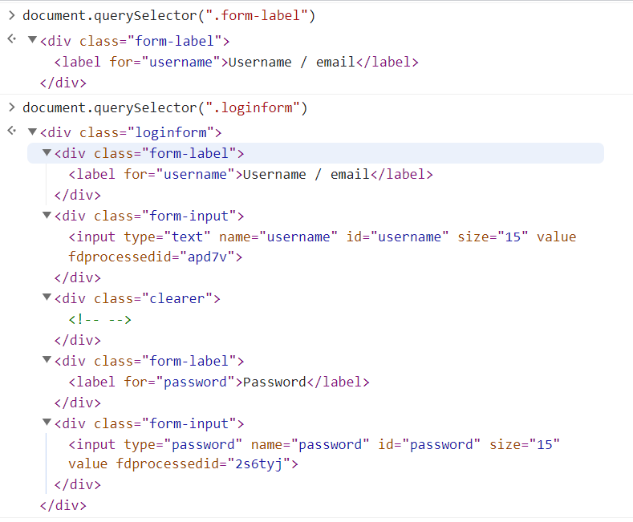

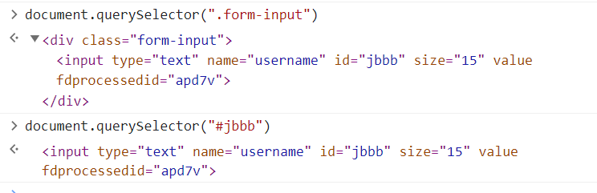

Here, properties like id, size and type can be changed accordingly.

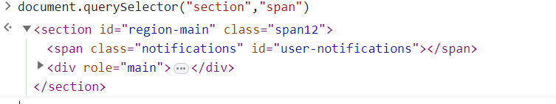

Document.querySelector(element1,element2) returns the element2 which is nested within the element as seen above.

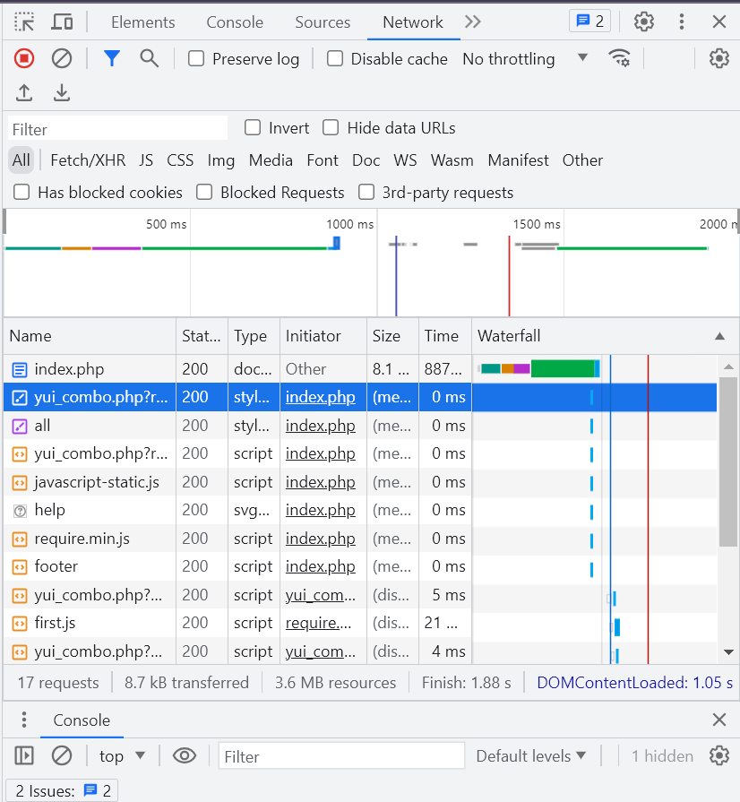

Tags corresponding to each name : (in order starting from the one highlighted)

1. <script id="firstthemesheet" type="text/css">

/** Required in order to fix style inclusion problems in IE with YUI **/

</script>

1. <link rel="stylesheet" type="text/css" href="https://moodle.iitd.ac.in/theme/styles.php/clean/1629522517_1/all"/>

1. <script type="text/javascript" src="https://moodle.iitd.ac.in/theme/yui_combo.php?rollup/3.17.2/yui-moodlesimple-min.js"></script>
2. <script type="text/javascript" src="https://moodle.iitd.ac.in/lib/javascript.php/1629522517/lib/javascript-static.js"></script>
3. <img class="icon iconhelp" alt="Help with Cookies must be enabled in your browser" title="Help with Cookies must be enabled in your browser" src="https://moodle.iitd.ac.in/theme/image.php/clean/core/1629522517/help"/>
4. <script type="text/javascript" src="https://moodle.iitd.ac.in/lib/javascript.php/1629522517/lib/requirejs/require.min.js"></script>
5. <script type="text/javascript" src="https://moodle.iitd.ac.in/theme/javascript.php/clean/1629522517/footer"></script>
6. <script type="text/javascript" src="https://moodle.iitd.ac.in/theme/yui_combo.php?rollup/3.17.2/yui-moodlesimple-min.js"></script>

*r.parentNode.insertBefore(o, r*) *(in javascript code)*

1. <script type="text/javascript" src="https://moodle.iitd.ac.in/lib/javascript.php/1629522517/lib/requirejs/require.min.js"></script>

*baseElement ? head.insertBefore(r, baseElement) : head.appendChild(r),*

*(In javascript code)*

1. <script type="text/javascript" src="https://moodle.iitd.ac.in/theme/yui_combo.php?rollup/3.17.2/yui-moodlesimple-min.js"></script>

*r.parentNode.insertBefore(o, r)* *(in javascript code)*

1. <script type="text/javascript" src="https://moodle.iitd.ac.in/theme/yui_combo.php?rollup/3.17.2/yui-moodlesimple-min.js"></script>

*r.parentNode.insertBefore(o, r) (in javascript code)*

1. <script type="text/javascript" src="https://moodle.iitd.ac.in/lib/javascript.php/1629522517/lib/requirejs/require.min.js"></script>

*baseElement ? head.insertBefore(r, baseElement) : head.appendChild(r),*

*(In javascript code)*

1. <script type="text/javascript" src="https://moodle.iitd.ac.in/theme/yui_combo.php?rollup/3.17.2/yui-moodlesimple-min.js"></script>

*r.parentNode.insertBefore(o, r) (in javascript code)*

1. <script type="text/javascript" src="https://moodle.iitd.ac.in/lib/javascript.php/1629522517/lib/requirejs/require.min.js"></script>

*h.send(b.hasContent && b.data || null) (in javascript code)*

1. <script type="text/javascript" src="https://moodle.iitd.ac.in/theme/yui_combo.php?rollup/3.17.2/yui-moodlesimple-min.js"></script>

*r.parentNode.insertBefore(o, r) (in javascript code)*

1. <script type="text/javascript" src="https://moodle.iitd.ac.in/lib/javascript.php/1629522517/lib/requirejs/require.min.js"></script>

*h.send(b.hasContent && b.data || null) (in javascript code)*

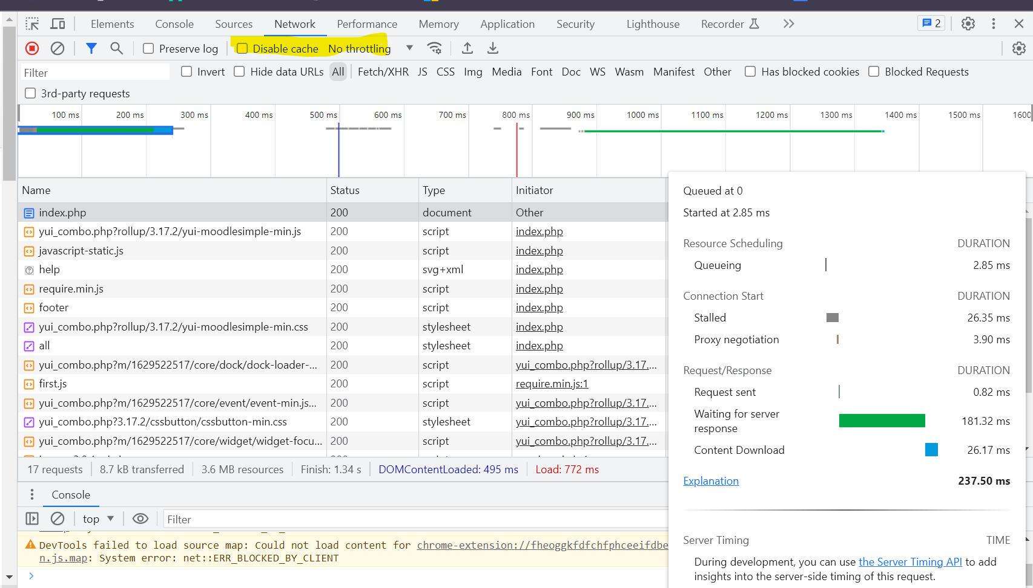

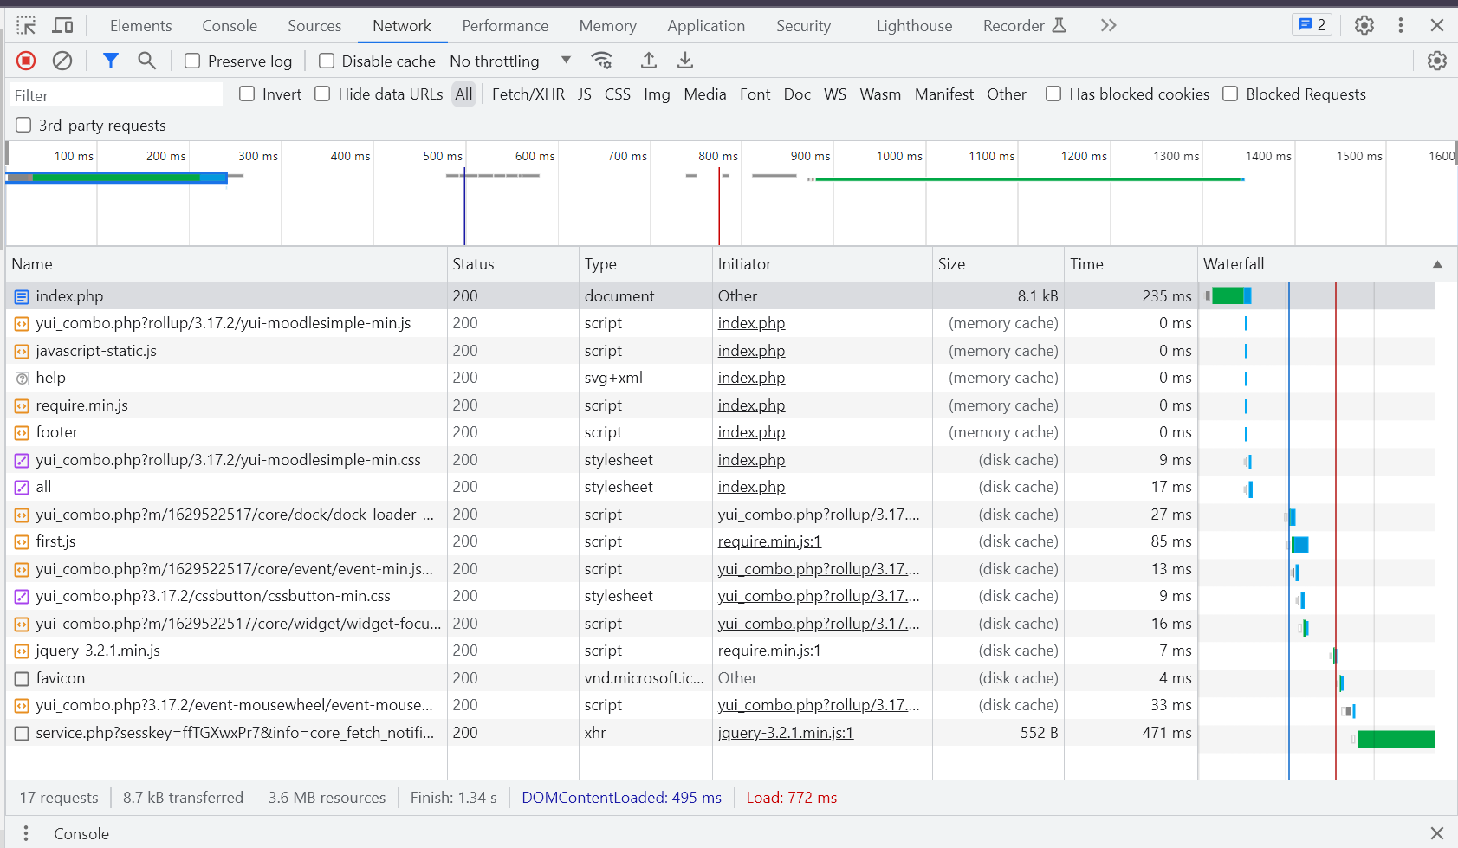

(With disable cache off and no throttling)

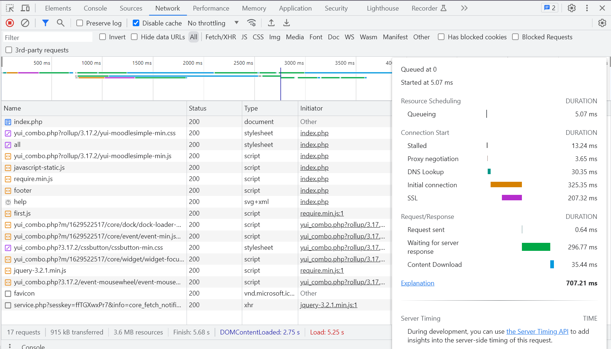



(With disable cache on and no throttling)

With disable cache, the loading time increases by about three times (or even more) than with memory and disk cache enabled. Thus this increases latency, but it is easier to edit with disabled cache.